**Project: Digital Ordering and Collection**

**customer journey**

**Arrival at the Restaurant:**

**Experience:** the moment the customer arrives and is dropped off at the designated entrance, the customer receives a notification via the restaurant app about arrival and estimated wait time. The customer receives a notification via the restaurant app about arrival and estimated wait time, along with a prompt to explore the menu.

**Entering the Restaurant:**

The customer is greeted by a welcoming atmosphere with digital menu boards displaying highlights and today’s specials; also, the app invites the customer to check the menu online, featuring photos and descriptions and the option to customize their order before check-in.

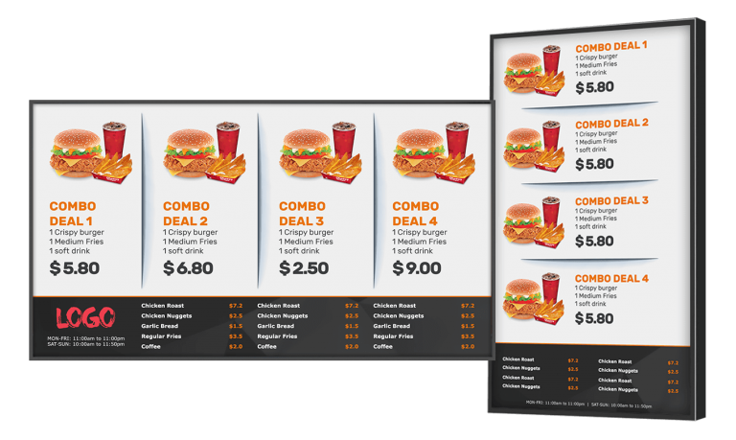

**Order Confirmation:**

The ordering can be made by check-in via app by using a QR code. After scanning the QR code, the app confirms the order details and provides additional information on the food preparation status.

The customer is shown an estimated wait time for their order, along with the option to explore the menu for future orders.

**Waiting area:**

By exploring this method, the customer waiting area will help to fill a more comfortable seating area with digital screens showing real-time order statuses, menu highlights, and ongoing promotions. By that being said, customers can browse the menu on their devices or screens for future visits, with suggested pairings for drinks or desserts.

**Order Collection:**

Collection Counter will be efficient because once the order is ready, the app notifies the customer via push notification for example ("Your order is ready for pickup!") or in silence because the notification repeats after a 1-min delay and with vibration in case the cell is in the pocket.

The customer approaches the collection counter, where staff are informed of the ready orders via a display synced with the app.

**Payment Confirmation (if not paid online):**

The payment process will be very important to the customer because if payment is required at the counter, a streamlined process is provided with various contactless payment options. Customers can complete payment effortlessly through a quick QR code scan or card reader.



**Feedback Opportunity:**

After collecting their order, customers receive a thanks message via the app and are encouraged to leave feedback.

A prompt appears on the app to submit a rating or review for their experience, fostering customer engagement.

**Departure:**

As customers exit, they see promotional materials for upcoming events or menu items. **Action:** The app reminds customers of loyalty points earned for their purchase, encouraging them to return.

This project addresses key challenges in the restaurant industry while also capitalizing on opportunities to enhance customer satisfaction and operational effectiveness.